Java: Java - High level, Object oriented, Platform independent, multi-threaded language able to write applications, web services and mobile applications.
Restrictions in java – goto statement, Multiple inheritance, operator overloading, call by reference
Object class is the root of inheritance.
Java program (.java files) are compiled into bytecodes (.class files) using the Java compiler (javac). A class loader, which is a component of the JVM loads the compiled Java bytecodes into specific areas called runtime data areas. Java execution engine, which is also a component of the JVM executes the Java bytecodes.
JDK – Software development environment used to develop, compile and run the applets and Java applications. SE, EE, ME. Combination of JRE and JVM
JRE – Implementation of JVM. Runtime Environment to run the java programs. Contains set of libraries that JVM uses on run time. JRE = JVM + class libraries (rt.jar) + other libraries.
JVM – Virtual Machine in which code executes. Enables computer to run a program. Compiles java code to byte code to machine independent. Runtime engine call the main method. Kick starts the main method of the java program
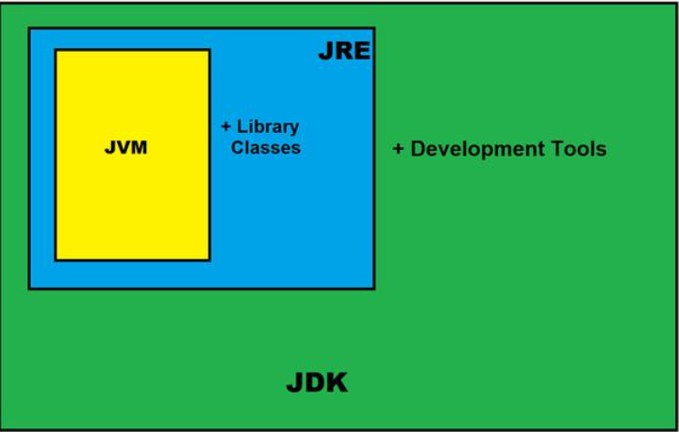
JVM Architecture
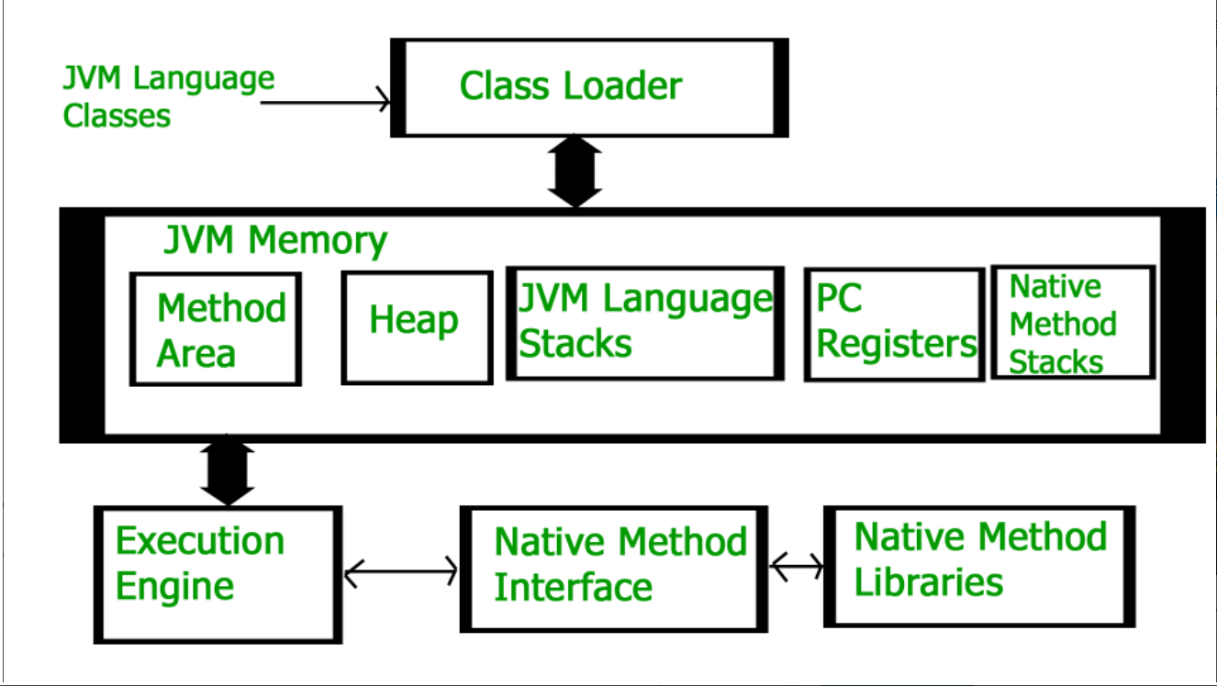

Class Loader Subsystem:
Subsystem of the JVM that loads, verifies the class file using byte code verifier.
Loading –Reads .class file and generate binary data for class and store in Method area. Loads the Fully Qualified name of the loaded .class file with immediate parent/interface/Enum and details like and modifier, variable and method information. After loading creates the object of the class in heap memory.
Linking:
- Verification: Ensures the correctness of the class file by checking the format and throw exception if any mismatch.
- Preparation: Allocate memory and initialize the static variables to default
- Resolution: Use direct reference of the class
Initialization – Initialize all the values that are present in the code to variables and methods. Executed from top to bottom.
Class Loader – The program is first loaded by the class loader once its executed and types of loaders are with respect to the path, they load the files.
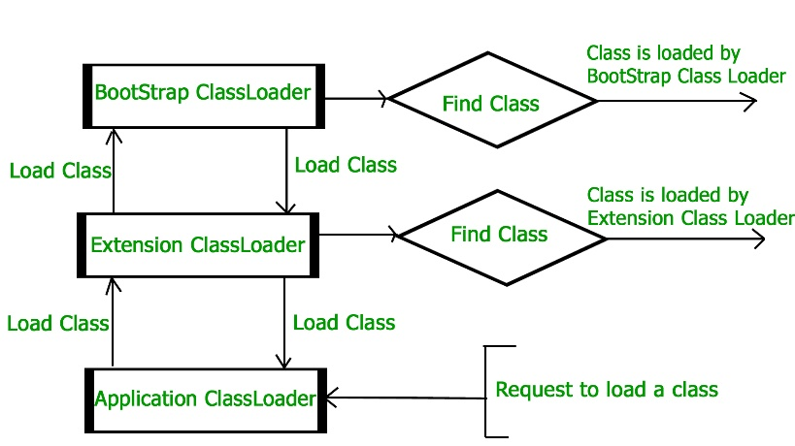
Bootstrap – It loads core java API classes present $JAVA_HOME/jre/lib and rt.jar file contains the SE edition like util, sql, .net package.
Extension – It loads the jar files inside $JAVA_HOME/jre/lib/ext directory.
System/Application: It loads files form application class path which we specified.
Memories in JVM:
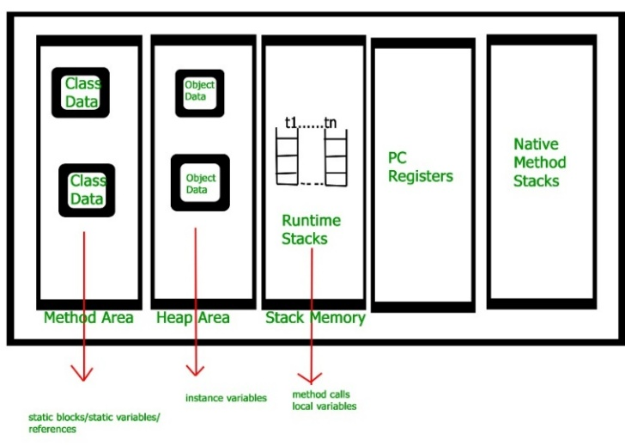
Class/Method area- Store class level information like immediate parent, methods data, variable/fields, static variables and runtime constant pools. Only one method area per JVM and shared resource.
Heap – Runtime memory is allocated to objects and information of all objects are stored in the Heap area. Only one heap area per JVM and shared resource.
Class/Method area and Heap are shared resource and one per JVM
Stack – Stores local variable and results memory partially, Frames are created when method invoke and destroy when it’s done. For each thread JVM creates a runtime stack and stores it and destroy once it’s done. Each block of stack stores method calls and not a shared resource.
Program Counter register: Stores address of JVM currently executed thread and each thread will have a separate pc register.
Native Method Stack: Uses native method to store memory.
Execution Engine: Executes the bytecode
- Interpreter: Interpret bytecode line by line and executes. If a method is called multiple times, interpretation is done multiple times.
- JIT Compiler: The JIT compiler helps improve the performance of Java programs by compiling bytecodes into native machine code at run time. The JIT compiler is enabled by default. When a method has been compiled, the JVM calls the compiled code of that method directly instead of interpreting it.
- Garbage Collection: Mechanism in the Java Virtual Machine (JVM) that automatically reclaims memory occupied by objects that are no longer needed or referenced by the program. This process eliminates the need for manual memory management, reducing the risk of memory leaks and errors. Used to destroy the unused memory in runtime. Null, referring to another reference, anonymous object.
Java Native Interface: Interface that interact with native method libraries. It enables JVM to call C/C++ libraries and to be called by C/C++ libraries which may be specific to hardware.
Native Method Libraries: These are collections of native libraries required for executing native methods. They include libraries written in languages like C and C++.
Write once and run anywhere – Compiler converts java program to byte code so its platform/machine independent.
Empty File can be executed in java and If you not pass any value in cmd line argument then string will assume as Empty and not null.
Order of specifiers is not a problem in java.
Access Modifiers in Java: Accessibility or scope of the field, method, class and constructor.
Public – Access to any class or method
Protected – Access to classes/subclass in same package
Private – Access with in class only
Default – Access with in the package
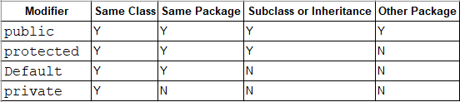
Compile and Execute Java:
Compile Java Class – javac <Filename.java>
Execute Java Class – java <Filename.java>
To run jar file: java -jar <jarfilename.jar>
-Xms and -Xmx is the minimum and maximum memory heap size which is allocated to JVM
This are the VM arguments passed in Java Application for OutofMemoryError issue.
-Xss to define the stack memory size and throws StackOverFlowError if stack is full.
Heap vs Stack:
Stack is used to store the order of method execution and local variables. Heap is used to store the objects and uses dynamic allocation and deallocation of memories.
https://www.digitalocean.com/community/tutorials/java-heap-space-vs-stack-memory
To kill Port in windows:
netstat -ano | findstr :8080
taskkill /PID <PID> /F
Java Beans:
A Java Bean is a Java class (conceptual) that should follow the following conventions:
- It should have a public no-argument constructor.
- It should be implemented serializable with serialization ID.
- It should have private fields.
- It should provide methods to set and get the values of the properties, known as getter and setter methods.
It is a reusable software component. It can encapsulate many objects into one object so that same object can be accessed from multiples places and is a step towards easy maintenance of code.
POJO(Plain Old Java Object): A normal java class object is a pojo class and it doesn’t has any restriction like Java Beans.
Compare enums: We can compare enum using == or equals(). equals() will throw null pointer exception.
Enum types ensure that only one instance of the constants exist in the JVM, we can safely use the “==” operator and it wont throw null pointer exception.
SOLID PRINCIPLES: SOLID principles are a set of guidelines for object-oriented programming in Java that help create flexible, maintainable, and robust software
Single-responsibility Principle (SRP): A class should have only one responsibility or job. A class should have one and only one reason to change, meaning that a class should have only one job.
Open-closed Principle (OCP): Classes should be open for extension but closed for modification. This means that a class's behavior can be extended without modifying the existing code.
Liskov Substitution Principle (LSP): Child classes should be able to replace their parent classes without affecting the program's correctness. Subtypes must be substitutable for their base types.
Interface Segregation Principle (ISP): A client should never be forced to implement an interface that it doesn’t use, or clients shouldn’t be forced to depend on methods they do not use. This was over comed by default methods in JDK 8
Dependency Inversion Principle (DIP): Entities must depend on abstractions, not on concretions. It states that the high-level module must not depend on the low-level module, but they should depend on abstractions.

